The Diane and Henry Ward Family Scholarship Fund
GUIDELINES

Eligibility

- The Diane and Henry Ward Family Scholarship Fund provides scholarships for graduating seniors from any high school in Erie County, PA.
- Scholarship recipients must be graduates of a high school in Erie County, PA and be residents of Erie County, PA.
- Scholarship recipients must be pursuing a degree in the healthcare field.
- Scholarship recipients must have an acceptance letter from an accredited institution including two and four year colleges.
- Scholarship recipients must have an acceptance letter from the school administration verifying attendance.

Criteria
- Grade Point Average — Applicants must have at least a 3.0 GPA on a 4.0 scale.
- Applicants must be enrolled in an accredited university or community college located in the U.S.
- Scholarships will be awarded to students based on financial need and scholastic achievement. High school transcripts must be included.
- All applicants must be a US. citizen or hold an official U.S. work authorization.

- Applicants must have an excellent attendance record, demonstrated commitment to community service and have a demonstrated need for financial support. An academic letter of recommendation must accompany the application.
- Applicants must submit a completed application as well as an essay of no more than 250 words describing how this scholarship grant will affect their education and future community service,

Applications available online at www.eriecommunityfoundaton.org

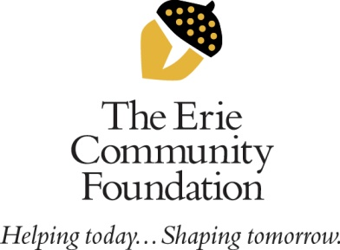

459 West Sixth Street
Erie, PA 16507

